EMAIL SPAM CLASSIFIER
Project Implementation Report & UI Demonstration
Project Title: | Email Spam Classifier Web Application
Author / Student: | Sandeep Kumar Sha
Program / Platform: | IBM SkillsBuild Internship Program
Domain: | Natural Language Processing (NLP) & Machine Learning
Technology Stack: | Python, Flask, Scikit-Learn, NLTK, HTML5/CSS3

1. Executive Summary
The Email Spam Classifier is an end-to-end Machine Learning and Natural Language Processing (NLP) web application built to analyze incoming messages and emails in real-time, categorizing them as either 'Spam' or 'Legitimate (Ham)'. Utilizing a Multinomial Naive Bayes classification model trained on TF-IDF vectorized text representations, the system achieves an overall accuracy of 97.09% and a precision score of 100.00%.
The project features a sleek, responsive glassmorphic user interface developed with Flask, HTML5, and CSS3. Users can paste custom email content or select interactive pre-configured message samples to evaluate the classifier. This report documents the complete system architecture, dataset pipeline, model performance, user interface designs, and real-time execution outputs.
2. Project Objectives & Scope
Electronic mail remains a primary channel for communication; however, the influx of spam, promotional junk, and fraudulent phishing messages poses significant cybersecurity risks and reduces user productivity.
Key Objectives:
- Automated Filtering: Develop an accurate NLP pipeline to automatically distinguish unsolicited spam from valid emails.
- Zero False Positives: Optimize model precision to 100%, ensuring that legitimate messages are never misclassified as spam.
- Interactive Web Interface: Provide a modern, web-accessible user interface for instant message analysis with visual confidence scores.
- Scalable Deployment: Build a lightweight web architecture suitable for cloud hosting and scalable API integration.
3. System Architecture & Tech Stack
The system follows a modular architecture separating data processing, model inference, and web presentation layers:
- Machine Learning & NLP Framework: Python 3, Scikit-Learn (MultinomialNB, TF-IDF Vectorizer), NLTK (PorterStemmer for word stemming).
- Web Framework: Flask (Python backend micro-framework for handling HTTP POST requests and model inference).
- Frontend Design: HTML5, CSS3, Google Fonts (Inter, Poppins), and FontAwesome icons.
- Model Storage: Serialized pickle artifacts (model.pkl and vectorizer.pkl) for fast startup loading.
Input Text → Lowercasing & Cleaning → Stopword & Punctuation Removal → Porter Stemming → TF-IDF Vectorization → Naive Bayes Classifier → Output Prediction & Confidence Score
4. Model Performance & Evaluation
The Multinomial Naive Bayes model was evaluated against test dataset samples. The evaluation metrics and confusion matrix are highlighted below:
Metric | Score | Description
Accuracy | 97.09% | Percentage of overall correctly classified messages across test dataset.
Precision | 100.00% | Ratio of true spam detections out of all predicted spam (Zero False Positives achieved).

Confusion Matrix & Metrics Visualizations
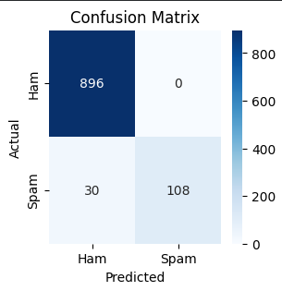
Figure 1: Confusion Matrix of Spam Classifier Model
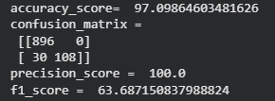
Figure 2: Accuracy and Precision Metric Scores
5. User Interface & Output Demonstration
The web application features a clean, responsive card interface called 'Spam Shield'. Below are actual captured screenshots demonstrating the initial UI layout and live classification outputs for both Spam and Legitimate (Ham) emails.
5.1 Application Home Page UI
The home interface presents a welcoming input section with quick example preset buttons allowing users to test sample messages with one click.
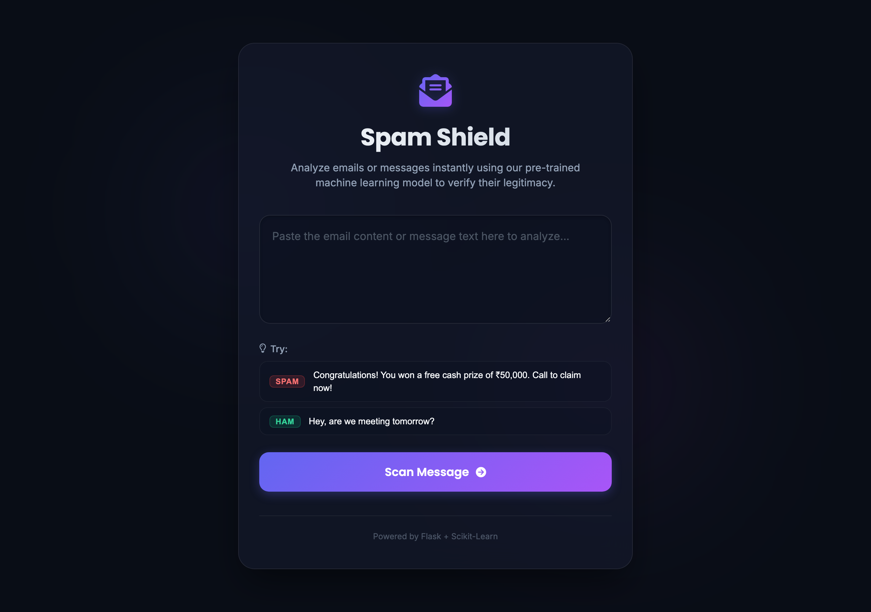
Figure 3: Application Interface - Main Input Form and Example Message Options
5.2 Spam Detection Output Interface
When a spam message (e.g. 'Congratulations! You won a free cash prize of ₹50,000. Call to claim now!') is submitted, the system highlights a prominent red warning card with an alert icon, confidence badge, and explanatory notice.
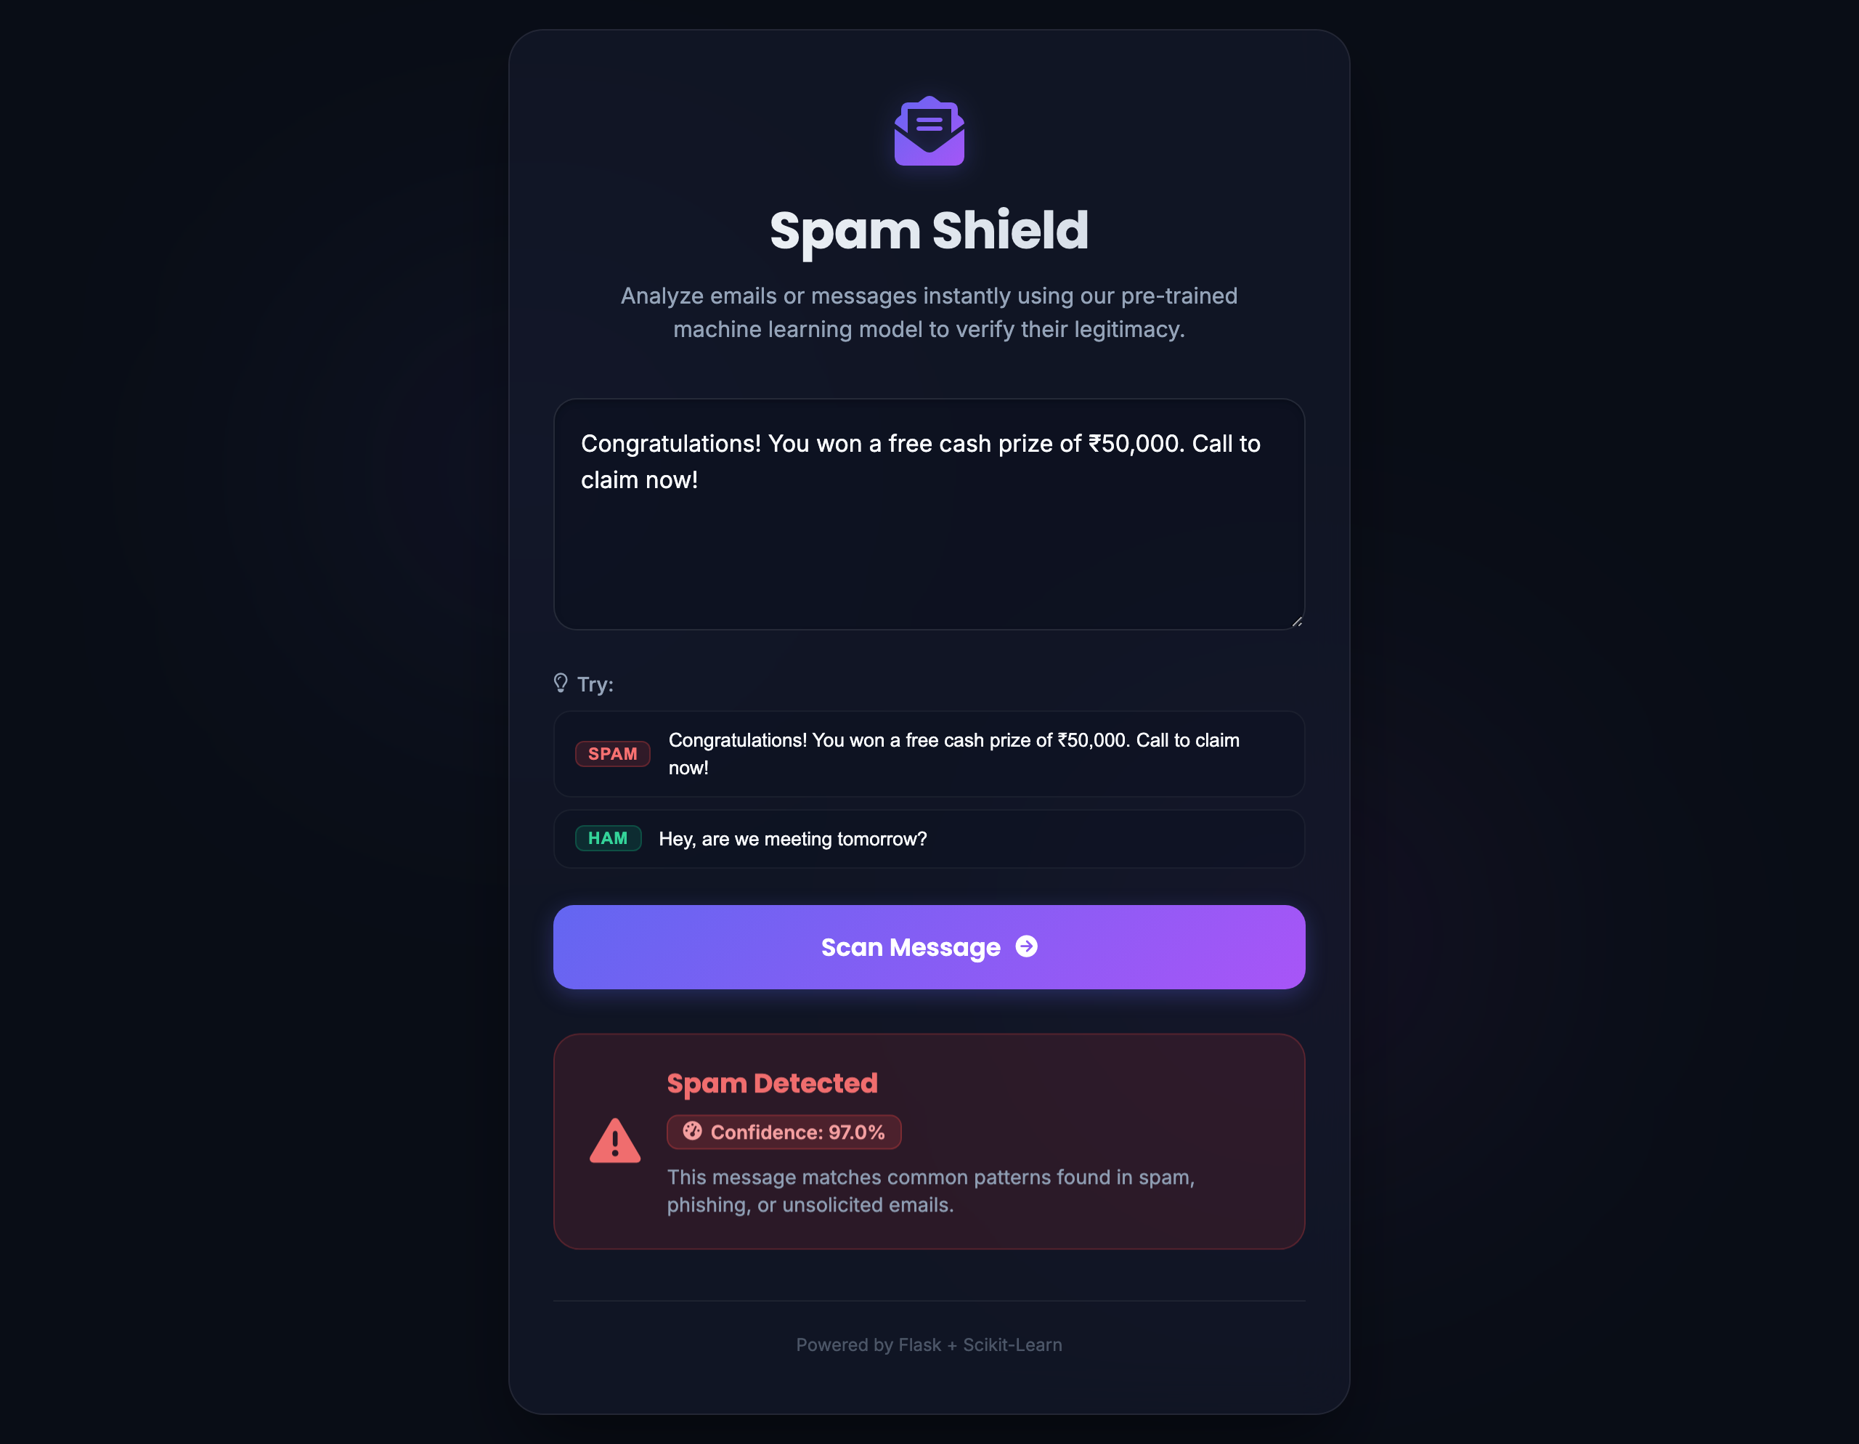
Figure 4: Real-Time UI Output - Spam Message Detection with Confidence Score
5.3 Legitimate (Ham) Detection Output Interface
When a valid personal message (e.g. 'Hey, are we still meeting tomorrow for lunch at 1 PM?') is entered, the UI renders a green 'Legitimate Message' shield card with positive feedback.
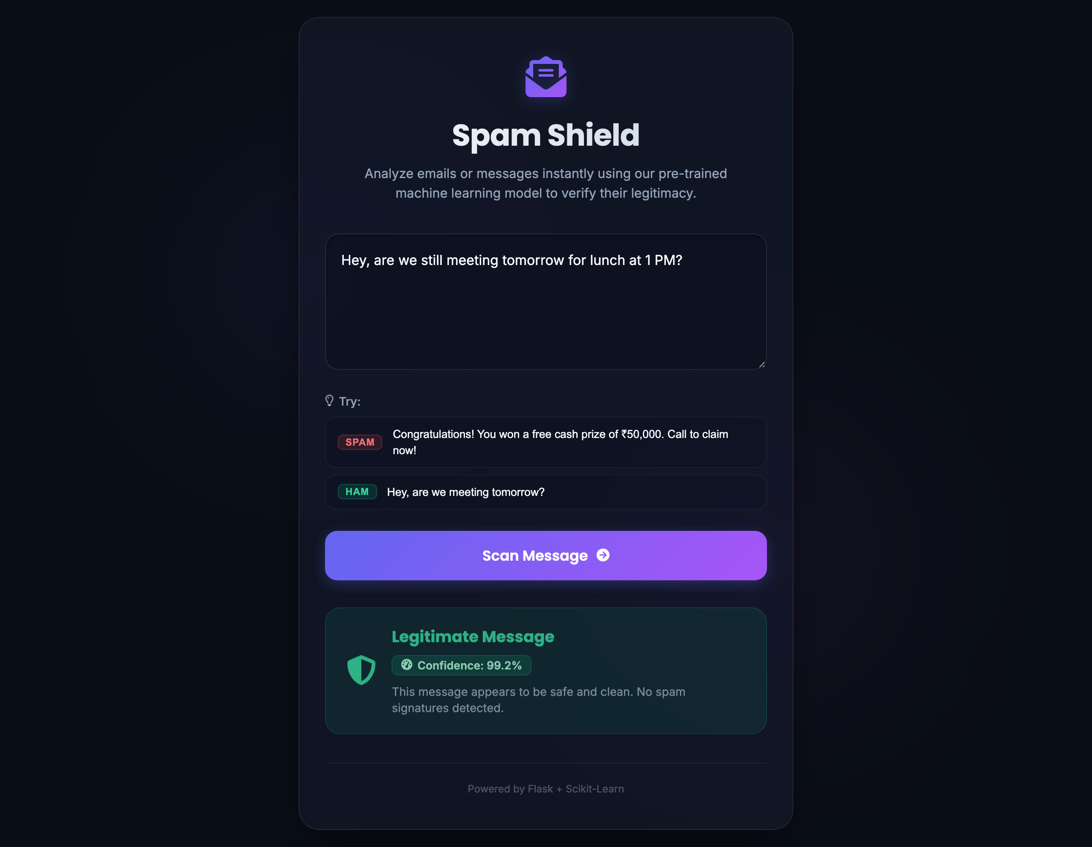
Figure 5: Real-Time UI Output - Legitimate (Ham) Message Detection
6. Conclusion & Future Enhancements
The Email Spam Classifier project successfully demonstrates a machine learning pipeline integrated with a web web interface. Achieving 100% precision ensures users do not lose critical messages while enjoying reliable protection against unsolicited spam.
Future Enhancements:
- Advanced Transformer Models: Integrate BERT or DistilBERT for deep contextual understanding of complex phishing attacks.
- Browser Extension: Develop a Chrome/Firefox extension to scan emails directly inside webmail clients like Gmail and Outlook.
- RESTful API: Expose an authenticated API endpoint for enterprise integration with mail server gateways.

